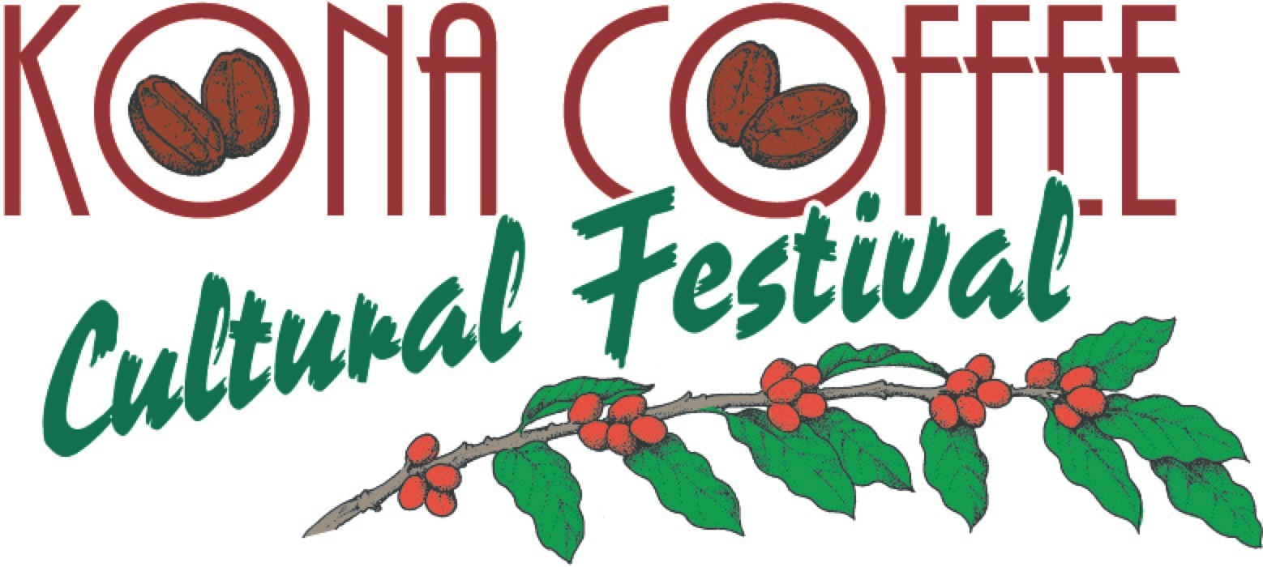

Festival Takes Home Four Golds

Every year, the Kona Coffee Cultural Festival strives to produce an experience enjoyed by the local community and visitors alike through the sharing of the unique history and culture of Kona coffee pioneers, farmers and artisans throughout the 10-day festival.

It is indeed an honor when Hawaii’s oldest food festival is recognized with accolades and awards.

Each year the International Festivals & Events Association recognizes outstanding accomplishments and top quality creative, promotional, operational and community outreach programs and materials produced by festivals and events around the world.

Three Kona Coffee Cultural Festival board members were on hand to accept a basket full of IFEA Haas & Wilkerson Pinnacle Awards.

Other Pinnacle Award winners included the Kentucky Derby and the National Cherry Blossom Festival in Washington DC.

Kona Coffee Cultural Festival IFEA Haas & Wilkerson Pinnacle Awards

Gold
Best Event Program or Magazine

Gold
Best Promotional Poster
Gold
Best Single Magazine Display Ad
Gold
Best Ad Series

Bronze
Grand Pinnacle

Previous Festival Awards include:

Best Fall Festival
National Geographic “Best Fall Festival in the United States.”
AARP “7 Fun Fall Festival Across the U.S.”
Frommer’s “Best Places to Go in 2020.”
National Geographic Traveler “The Best Food Festival in Every U.S. State.”
Fodor’s “Weird Fall Food Festivals.”
Country Living Magazine “29 Best Fall Festivals and Fairs Across the United States.”
Expedia Viewfinder’s “Essential Fall Experiences across America.”
Country Living magazine“22 of the Best Fall Festivals to Celebrate the Season.”

World’s Best
Lonely Planet's Global Coffee Tour book listed Kona Coffee Cultural Festival as a world's best coffee experience.

