“I think the Kona coffee has a richer flavor than any other, be it grown where it may and call it by what name you please.”
Mark Twain

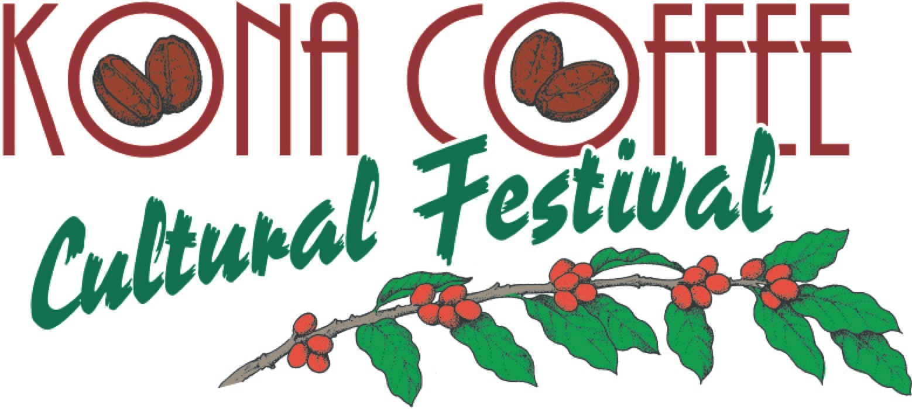

Mark Twain’s Letters from Hawaii

At the young age of twenty-seven, Twain came to Hawaii under contract with the Sacramento Union to pen twenty five stories about the Sandwich Isles. It’s said that his lifetime love affair with Hawaii did not dim, instead, more than one hundred and fifty years after his visit to Hawaii, what he wrote is still being quoted, discussed and much loved.

Twain had just set foot in Kona, Hawaii after sailing on the schooner Boomerang from Honolulu in July 1866. It’s here we begin America’s famous writer’s recount of his visit to Kona.

“We landed at Kailua, a little collection of native grass houses reposing under tall coconut trees–the sleepiest, quietest, Sundayest looking place you can imagine. Ye weary ones that are sick of the labor and care, and the bewildering turmoil of the great world, and sigh for a land where ye may fold your tired hands and slumber your lives peacefully away, pack up your carpet sacks and go to Kailua! A week there ought to cure the saddest of you all.”

Twain writes of his journey on horseback from Kailua to Kealakekua Bay, where his ride took him through the famous coffee and orange sections of the Kona District. He wrote that the coffee plantations they came across looked well and were expecting the crop to do unusually well. According to Twain, the orange crops that grew in Kona during 1866 were impressive. He noted that Kona exported about 500,000 oranges in 1865 to California, its principle market. We can speculate that these oranges, rich in vitamin C, were well sought after by ships and sailing crews as a food source to prevent scurvy. In his Letters from Hawaii writings, Twain notes, “We passed one orchard that contained ten thousand orange trees.” Today, we know this land as Greenwell Farms.

In 1850, Henry Nicholas Greenwell settled into Kealakekua where he and his wife Elizabeth spent the next 40 years farming and producing Kona coffee. It was his land of orange trees that Twain spoke of. In 1873, Kona coffee caught the attention of coffee lovers everywhere, when Greenwell traveled to the World’s Fair in Austria. The coffee he carried with him from Kona was awarded a “Recognition Diploma” by the President of the Kaiser’s Exposition. This was Kona coffee’s first award. Today, the flavor characteristics of Kona coffee is what makes it famously known around the world.

###
Festival Accolades
Lonely Planet's Global Coffee Tour book listed the Kona Coffee Cultural Festival as a “world's best coffee experience.” National Geographic recently wrote that the “Festival is a Best Fall Festival in the United States” with the National Geographic Traveler listing the Kona Coffee Cultural Festival as a “Best Food Festival in Every U.S. State.” Country Living Magazine included this year’s Festival as one of the “Best Fall Festivals and Fairs Across the United States” and earlier as a “Best Fall Festival to Celebrate the Season.”

About Kona Coffee Cultural Festival
The award-winning Kona Coffee Cultural Festival is recognized as the oldest and one of the most successful food festivals in Hawaii. The ten days of events promote Hawaii’s unique culture and diversity and supports the Festival’s mission to preserve, perpetuate and promote Kona’s unique coffee heritage.

Note to editors: For high-resolution Coffee Festival images or to schedule an interview, contact Laura Aquino at 808.326.7820 or email laura@current-events.com.

