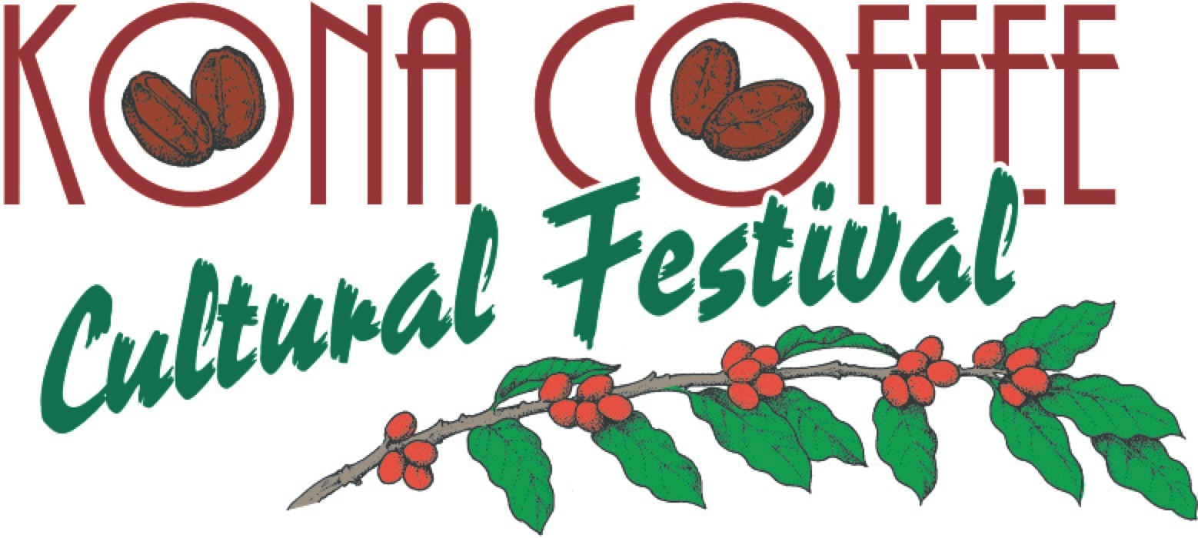

Speak Like a Kona Coffee Farmer

Kona coffee has been growing here for nearly 200 years. Many farms offer wonderful, interesting tours, giving in-depth looks into growing Kona’s famous coffee. Here are just a few things you might want to know.

Growing
Kona coffee farms fill the landscape, sometimes as far as the eye can see. Each tree branch will produce blooms from late winter to early spring. These sweet-smelling fragile white blossoms only last for a few days. Imagine a Kona coffee farm covered in white blossoms, we call it “Kona Snow.”

Harvesting
Harvesting begins in the early fall through late winter. Kona coffee is picked by hand and a picker needs a sharp eye and nimble fingers to only pluck ripe cherry from the branch. An experienced picker can pick 200 to 400 pounds each day.

Each day the coffee harvest begins its processing, including removing the red outer skin from the beans, fermenting, and finally drying.

Traditional drying of Kona coffee is done on a Hoshidana, a covered roof platform. The beans are evenly laid out on the Hoshidana. Each morning, the roof is pushed back letting the coffee dry in the hot Kona sun. A unique wooden rake is used many times during the day to stir the drying coffee beans. Before the expected afternoon rain, the platform roof is pushed back. This is repeated for several days until the coffee beans are dry.

Roasting
It has taken some time to get here but this is the final stage before Kona’s famous coffee is poured into your cup. Roasting is part science part skill, leaving enough room for each roaster’s preferred signature roast.

-more-

Enjoying
Kona coffee is roasted to either Light, Medium, or Dark, the choice is yours. When visiting the many Kona coffee farms, be sure to taste their signature roasts. Cheers!

###
Festival Accolades
Lonely Planet's Global Coffee Tour book listed the Kona Coffee Cultural Festival as a “world's best coffee experience.” National Geographic recently wrote that the “Festival is a Best Fall Festival in the United States” with the National Geographic Traveler listing the Kona Coffee Cultural Festival as a “Best Food Festival in Every U.S. State.” Country Living Magazine included this year’s Festival as one of the “Best Fall Festivals and Fairs Across the United States” and earlier as a “Best Fall Festival to Celebrate the Season.”

About Kona Coffee Cultural Festival
The award-winning Kona Coffee Cultural Festival is recognized as the oldest and one of the most successful food festivals in Hawaii. The ten days of events promote Hawaii’s unique culture and diversity and supports the Festival’s mission to preserve, perpetuate and promote Kona’s unique coffee heritage.

Note to editors: For high-resolution Coffee Festival images or to schedule an interview, contact Laura Aquino at 808.326.7820 or email laura@current-events.com.

