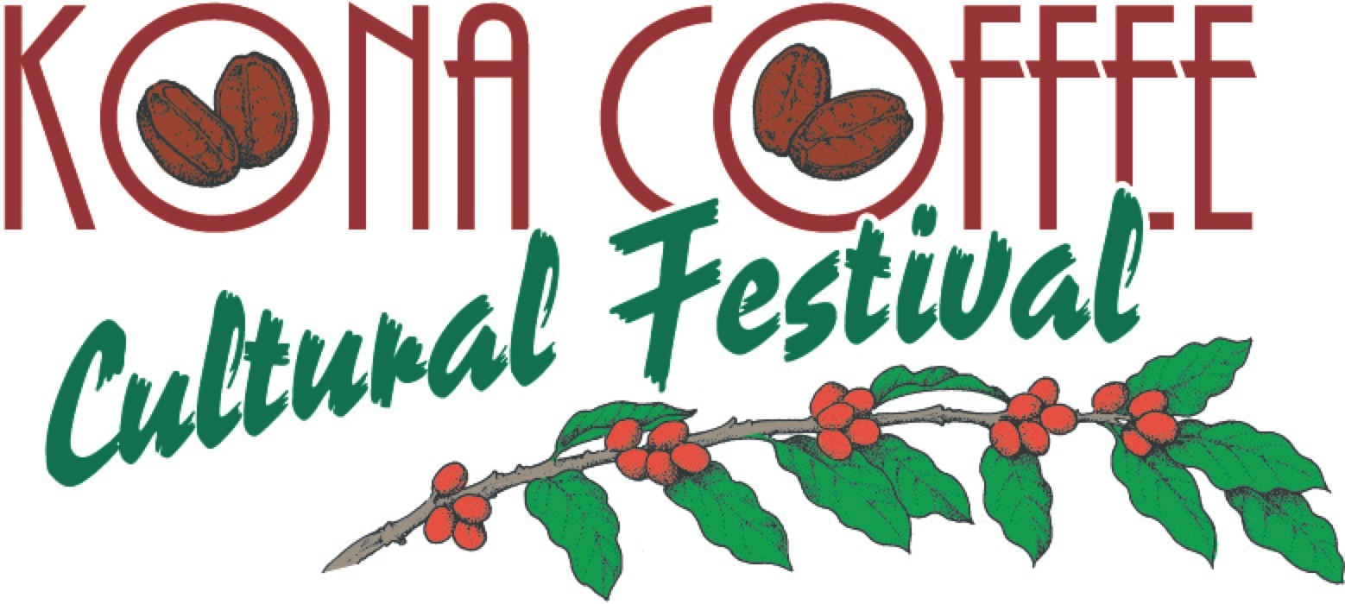

The Festival Experience

Kona Coffee Cultural Festival experience is unique, enriching and ensures that the story of Kona coffee’s cultural heritage continues to be shared with residents and visitors.

The cultural heritage of Kona’s coffee industry is built on the multi-generational tenant farmers, mainly of Japanese descent who established coffee plantations in the Kona District along with the native Hawaiian host culture who had earlier ties to growing coffee here in Kona.

Each year in November, Kona coffee’s world-renown reputation along with the unique cultural heritage of the past tells the story of coffee traditions that produced this American legacy. Not to mention its mission to preserve, perpetuate and promote Kona's unique nearly 200-year coffee history.

Event participation includes Japanese community members who bring the coffee pioneers’ story to life by depicting the daily lives of early Japanese immigrants during the period of 1920-1945 through an interpretive historic coffee farm, bon dance participation, Japanese lantern parade participation and hands-on cultural opportunities. Latina community members share dance, local Filipino clubs share food experiences and Native Hawaiian community members pass on their skills in the arts, traditions and practices including kapa masters, ipu masters who instruct visitors and residents on the lost art of Niihau gourd designing, lauhala weavers of all ethnicity who work together to perpetuate this vibrant piece of Native Hawaiian craft and educational native floral design and lei making classes.

Other Festival events spotlight Hawaiian music, song, and the Aloha spirit found throughout all of Hawaii.

###
Festival Accolades
Lonely Planet's Global Coffee Tour book listed the Kona Coffee Cultural Festival as a “world's best coffee experience.” National Geographic recently wrote that the “Festival is a Best Fall Festival in the United States” with the National Geographic Traveler listing the Kona Coffee Cultural Festival as a “Best Food Festival in Every U.S. State.” Country Living Magazine included this year’s Festival as one of the “Best Fall Festivals and Fairs Across the United States” and earlier as a “Best Fall Festival to Celebrate the Season.”

About Kona Coffee Cultural Festival
The award-winning Kona Coffee Cultural Festival is recognized as the oldest and one of the most successful food festivals in Hawaii. The ten days of events promote Hawaii’s unique culture and diversity and supports the Festival’s mission to preserve, perpetuate and promote Kona’s unique coffee heritage.

Note to editors: For high-resolution Coffee Festival images or to schedule an interview, contact Laura Aquino at 808.326.7820 or email laura@current-events.com.

